**Home task 7,8**

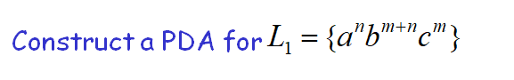

construct a PDA for Language Palindrome for alphabet a,b.